**Using MUSIC-*link* for Hornsby Shire Council**

In order to improve the development assessment process with regards to Water Sensitive Urban Design, Council is working with eWater to simplify the process of developing Stormwater Treatment Strategies. The use of **MUSIC**-***link*** can simplify the development and assessment of MUSIC models.

As such, Council encourages proponents to utilise the **MUSIC***-link* function when preparing MUSIC models for proposed developments within the Hornsby Shire Council.

When Hornsby Shire Council is assessing a development proposal, we must check that it complies with our Water Sensitive Urban Design policies. While eWater's **MUSIC** software makes it possible to achieve compliance with the targets and parameters, the assessment and refinement process has traditionally been iterative and time-consuming.

The main benefit of **MUSIC**-***link*** is that developers and consultants can design their stormwater management infrastructure and then immediately validate it (within the software) to ensure that parameters fall within the limits of Hornsby Shire Council's requirements. On receiving a submitted design and related validation report, our Development Assessment team can immediately check for compliance with our standards. If the design is compliance, it can be passed onto engineers for detailed evaluation.

**MUSIC**-***link*** streamlines the process of achieving a match between the Hornsby Shire Council's specific guidelines and urban developers' water sensitive designs. This shortcut bypasses the traditionally iterative process, where assessing authorities returned models to developers to be amended and re-submitted until they are suitable for engineering evaluation.

MUSIC-***link*** allows Hornsby Shire Council to:

* Apply a simple, robust and quicker process of WSUD assessment, helped by the compliance report that **MUSIC**-***link*** provides with designs;
* Communicate clearly and directly with developers and designers, providing locally specific WSUD requirements and modelling parameters;
* Provide increased levels of redundancy for model assessment; and
* Build capacity and support policy redundancy to support longevity.

**Using MUSIC-*link***

**MUSIC**-***link*** forms part of the standard **MUSIC** v6 interface, and can be accessed using the **MUSIC**-***link*** tab (shown below) in the main interface.

**MUSIC-*link* tab**

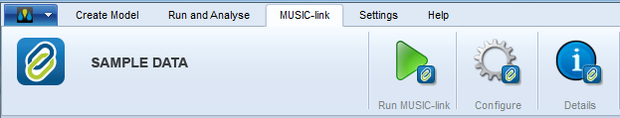

Validate **MUSIC-*link*** Model

Working with **MUSIC**-***link*** is a two-step process:

1. Create and run your **MUSIC** model; and
2. Validate you model against the set of pre-defined parameters for a particular assessing authority.

**Creating a MUSIC model**

When creating a **MUSIC** model for inclusion in the validation process, you can choose one of two methods: either create a standard model, or directly create a **MUSIC**-***link*** model, as described below.

**Create a standard model**

* Choose a standard meteorological template that is available with **MUSIC**;
* Build and run your **MUSIC** model;
* In the **MUSIC**-***link*** tab, click ***Configure*** and choose ***Yes*** to convert the existing model to a **MUSIC**-***link*** model;
* Choose Hornsby Shire Council and the associated meteorological template from the **MUSIC**-***link*** Configuration window that opens (as per below diagrams); and
* Then, initiate the validation process. Refer to Validating the **MUSIC**-***link*** model for details.

**Directly create a MUSIC-*link* model**

* Choose **New MUSIC-*link*** from the main **MUSIC** tab;
* Choose the Hornsby Shire Council option from the drop down list and the associated meteorological template (as shown below);
* Build your model; and
* Then, initiate the validation process. Refer to **Validating the MUSIC-*link*** model for details.

**Note:** When using MUSIC-link, nodes with import flows do not contribute to the total areas or the impervious percentage calculations

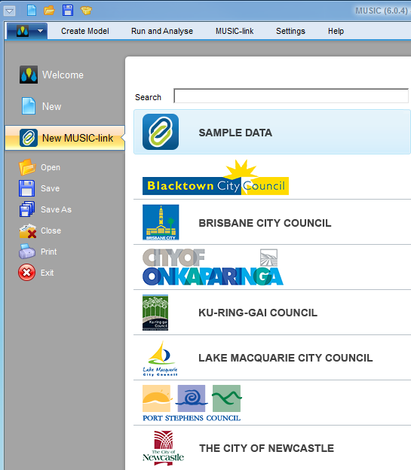

Access to **MUSIC-*link*** with the names of assessing authorities from main **MUSIC** tab (only a partial list is shown in this figure)

**Self-Validating the MUSIC-*link* model (Prior to lodgement with Hornsby Shire Council)**

Ensure that your **MUSIC** model has been created with Hornsby Shire Council inputs prior to validating it. Once you have created your model:

1. Choose the **MUSIC-*link*** tab and click **Run MUSIC-*link***; and
2. Once the model has been run, the **MUSIC**-***link*** window appears showing the validation report (see below).

**Validation report**

A report is generated on completion of a validation run (as shown below). The top half of the report provides details of the validation result. It shows the compliance status of each parameter, which indicates whether the result in within the allowable range. An unchanged result indicates that this value has not been modified by the user (default value used during model run), and hence, it has no effect on overall compliance.

You can now do the following with the report:

* Click ***Create Report*** to expand a form, where you can enter details of the project & associated notes as well as contact details for those who are submitting the model & report. A report will only be generated (and can be saved in a PDF format) if all the parameters are compliant, or you have provided an explanation to justify why parameters are non-compliant (using the ***Comment*** field)
* Click ***Next Steps*** to expand the report for Hornsby Shire Council lodgement Instructions.

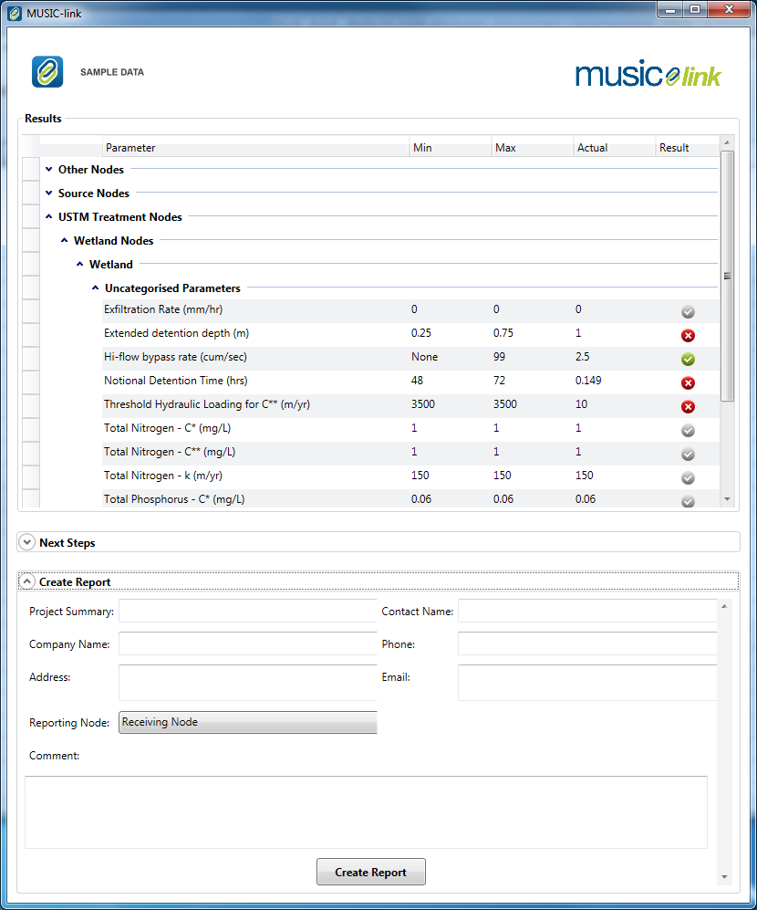

Compliance Status

Range of allowable values

Passed

Failed

Unchanged

**Lodgement of your MUSIC model and MUSIC-*link* Report to Hornsby Shire Council**

If the MUSIC model meets the reportable parameter requirements for Hornsby Shire Council’s setup configuration and targets, proceed as follows:

1. Create/Generate a Hornsby Shire Council **MUSIC**-***link*** PDF report for submission with your model;
2. Submit your self-validated **MUSIC** model along with the Hornsby Shire Council **MUSIC**-***link*** PDF report to Hornsby Shire Council as part of your Development Application.

If the parameters and/or targets are outside the required ranges and you believe the use of these parameters or the output results can be justified, please follow the steps below:

1. Generate a Hornsby Shire Council **MUSIC**-***link*** PDF report for submission with your model. **NOTE**: Any parameter breaches must be justified for the model to be considered by Hornsby Shire Council;
2. Provide reasons for model assumptions that are outside of default parameter ranges in the **Comments** section; and/or
3. Submit your self-validated **MUSIC** model along with the Hornsby Shire Council **MUSIC**-***link*** PDF report to Hornsby Shire Council as part of your Development Application.

**All material submitted must be in accordance with Hornsby Shire Council’s DA submission requirements.**

**Further Assistance:**

If you require further assistance with utilising MUSIC-link Hornsby Shire Council, please contact eWater support on 1300 92 837 support@ewater.com.au or Hornsby Shire Council on02 9847 6664 devmail@hornsby.nsw.gov.au, during office hours.